Note: This document is “view only”. Please create a copy of this document and save it to your drive.

**SOP- Archiving Standard Operating Procedure- Systems Vault**

**PREREQUISITES**

[Master: SOP- Standard Operating Procedures- Systems Vault](https://docs.google.com/document/u/0/d/1P8URSBV8z47y77ZGJGUbzm-qVnItlp-NJmbVZygxfIM/edit)

Google Drive

[Master: Guidelines- Naming Conventions- Systems Vault](https://docs.google.com/document/u/0/d/1IsYwJoykfoADN6hC3jGEgms5vz92vpVEAHWlxIMMJW8/edit)

[Master: SOPs- Systems Vault](https://docs.google.com/spreadsheets/u/0/d/1z1XxJf0lB-WdKR4mwtZVZffvMCbQZgRgtZTYUzNiMCE/edit)

z. SN ARCHIVE (SOPs - Internal)- Sarah Noked OBM

**PURPOSE**SOPs are our bread and butter. We archive SOPs to ensure that we aren’t following old procedures and to keep our SOP folders clean.

**POLICY**

When modifying SOPs always use your @sarahnoked.com to login to Google Drive

All archived SOPs must be prefaced with the correct naming convention as indicated here: [Master: Guidelines- Naming Conventions- Systems Vault](https://docs.google.com/document/u/0/d/1IsYwJoykfoADN6hC3jGEgms5vz92vpVEAHWlxIMMJW8/edit)

All Archived SOPs are moved to this folder: z. SN ARCHIVE (SOPs - Internal)- Sarah Noked OBM

**PARTY**

All Team Members

**PROPERTY**

Online Business Manager

**PROCESS**

Part 1: Update the SOP for Archiving

Part 2: Move the Archived SOP to the correct folder

**PROCEDURE**

**Part 1: Update the SOP for Archiving**

1. Login to Google Drive
2. Navigate to the SOP you want to archive
3. Rename this SOP using the naming conventions [Master: Guidelines- Naming Conventions- Systems Vault](https://docs.google.com/document/u/0/d/1IsYwJoykfoADN6hC3jGEgms5vz92vpVEAHWlxIMMJW8/edit)

**Part 2: Move the Archived SOP to the correct folder**

1. Move the SOP to the z. SN ARCHIVE (SOPs - Internal)- Sarah Noked OBM
   1. From the document click file > Move

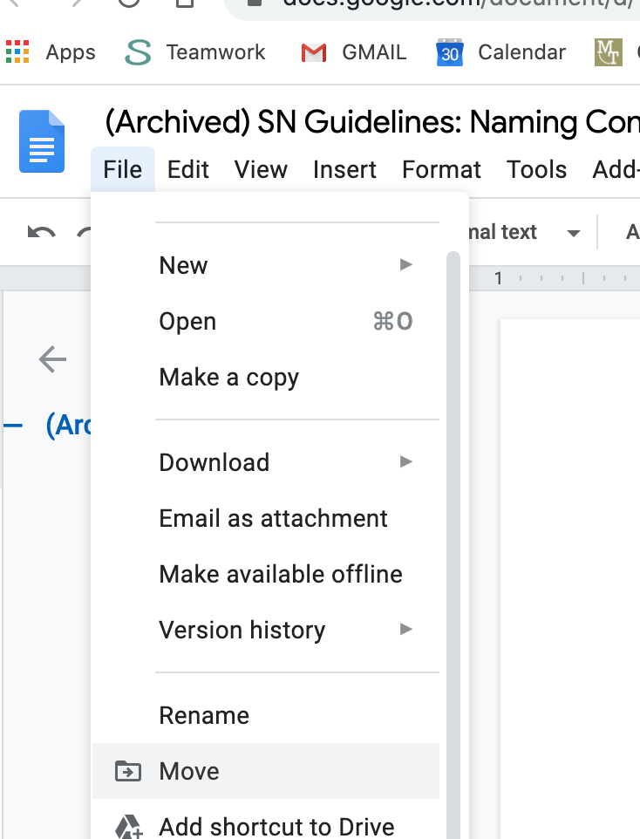

* 1. Move the supporting docs and files to z. SN ARCHIVE (SOPs - Internal)- Sarah Noked OBM

**Created by:**

**Department:** Growth

**Date:**

**Revised:**

**Revised by:**